Robotic process automation (RPA)

Iris Technology Capabilities

Iris Software, Inc.

Contents

Summary 3

About IRIS Software Inc. 3

What is RPA 3

1. RPA Automation Center of Excellence 3

2.1 Process & Governance 4

2.2 Tools and Accelerators 5

2.3 RPA Implementation Methodology 7

2.4 People 7

2. RPA Services Portfolio 8

2.1. Digital Processes 9

2.1.1. Digital Business Models 9

2.1.2. Digital Technologies 9

2.1.2.1. Process Automation 9

2.1.2.2. Predictive Analytics 9

2.1.2.3. Machine Learning 9

2.1.2.4. Natural Language Processing 9

2.1.2.5. Text & Image Processing 9

2.1.2.6. Speech Recognition & Command 9

2.1.2.7. Internet of Things 9

2.2. Process Project Portfolio Management 9

2.2.1. Process Identification & Prioritization 9

2.2.2. Process Architectures 9

2.2.3. Process Project Planning 9

2.2.4. Project Portfolios 9

2.3. Business Process Management 9

2.4. Process Improvement & Innovation 9

2.4.1. Process Analysis & Improvement 9

2.4.2. Process Industrialization 9

2.4.3. Process Innovation 9

2.5. Process Monitoring & Control 9

2.5.1. Process Performance Indicators 9

2.5.2. Real time Process Control 9

2.5.3. Data Driven processes 10

2.5.4. Process Deviance Management 10

Step 4: RPA Service Portfolio 10

4.1 Automation Services 10

Step 5: Tool and Technologies 12

Step 6: Automation Methodology 12

Step 7: Process Automation Approach 12

Step 11: Conclusion 15

# Summary

# About IRIS Software Inc.

Iris is a leading IT solutions provider, offering applications, solutions and services globally through a combination of technology knowhow, domain and process expertise. We are headquartered in Edison, NJ and have offices in New York City, Chicago and Toronto. Our offshore delivery center (ODC) is located in Noida, India. We are a team of 800+ software professionals across the U.S., Canada and India. We are an ISO 9001:2008 & ISO 27001:2005 Certified and CMMI v 1.3 Level 4 assessed company. Our clients include RBC (Investment Bank and Wealth Management), FolioDynamix, Private Client Resources (PCR), Lord Abbett, UBS, Merrill Lynch, TD Ameritrade, etc. We are privately owned, debt free, profitable and cash positive

* 2014 annual revenue of approximately $80M

## What is RPA

**Robotic Process Automation** delivers direct profitability while improving accuracy across organizations and industries. Designed to perform on a vast range of repetitive tasks, software robots interpret, trigger responses and communicate with other systems just like humans do. Only substantially better: a robot never sleeps, makes zero mistakes and costs a lot less than an employee.

Enabling RPA to handle any processes will not only transform and streamline your organization’s workflow. It will allow for superior scalability and flexibility within the enterprise, doubled by fast, tailored response to specific needs. Software robots are easy to train and they integrate seamlessly into any system. Multiply them, and instantly deploy more as you go. They constantly report on their progress so you can go even bigger and better by using operational and business predictability, while improving strategically.

## RPA Automation Center of Excellence

Regardless of its task, a robot’s essential job is to make the company vision come true. In our approach to automation, we think of RPA as a long-range capability meant to empower organizations to evolve strategically and increase business value.

To achieve this goal, we advise our customers and assist them towards developing an effective & efficient Robotic Process Automation journey an internal, self-sustaining and scalable RPA expertise to run and maintain robots. Center of Excellence (CoE) is essentially the way to embed RPA deeply and effectively, and distributes accumulated knowledge and resources across future deployments.

We enable you to:

* Introduce and enhance the business process management and keep the objectives aligned with the Organizations Agility.
* Define a vision and implementation road map
* Establish a governance mechanism
* Set up components of the RPA CoE-like Infrastructure & Tools setup and manage.
* Communicate regularly at all organizational levels.
* Ensure smooth progress of the implementation.

We help you:

* Create & Manage Process Performance Indicators.
* Manage real time process control.
* Minimize production support costs by automating & optimizing the process automations in the system.
* Deliver higher customer satisfaction and employee engagement with improved quality of software
* Minimize time to market for new functionality
* Achieve a culture of high performance and high job satisfaction.
* Standardized Customer Engagement Models
* Continuous Feedback & Improvement Mechanism
* Metrics Management
* Best Practices Implementation
* Adhering to Customer Compliance

## 2.1 Process & Governance

**a) Standardized Templates, Checklists** – This includes the List of Documents which includes the standard coding templates for estimations, design, develop & deliver.

**b) RPA Metrics Management –** Automated testing metrics are metrics used to measure the performance (past, present, and future) of the implemented automated testing process and related efforts and artifacts. Automated testing metrics serve to enhance and complement general automation metrics, providing a measure of the AST coverage, progress, and quality, not replace them.

And these metrics play an important role in controlling & monitoring ROI for the RPA implementation.

**A typical template for metrics looks like –**

|  |  |  |
| --- | --- | --- |
| **Candidate Process Automation Review** | | |
| Organization | **XYZ Company** | |
| Process Name | **So n So process** | |
| Process Name Provided By (Name, Title/Role): | **Mr. X, Operations Director** | |
| Briefly describe the Process and Indicate why it is being considered for RPA | **Process is to …** | |
| What are the post-automation goals for this process? (ie., cost reduction, error reate elimination, increased cycle times, scalability, etc) | **Goals are to …** | |
| **Process Definition Metrics** | **Input** | **Comments** |
| ***C*** | **C3** | **C2** |
| ***Number of FTEs currently performing process*** | 0 | Comments go here if additional explaination needed |
| ***Number of Minutes it currently averages for one complete cycle of the process*** |  | Comments go here if additional explaination needed |
| ***Number of times process executed per day*** | 0 | Comments go here if additional explaination needed |
| ***Number of times process executed per month*** | 0 | Comments go here if additional explaination needed |
| ***How consistent is transaction volume from month to month*** | H/M/L | Comments go here if additional explaination needed |
| ***What percentage of process volume requires exception management?*** | 0 | Comments go here if additional explaination needed |
| ***How many months will this process continue to be required*** | 0 | Comments go here if additional explaination needed |
| ***What is the per transaction cost to execute this process?*** | $0.00 | Comments go here if additional explaination needed |

**c) Best Practices Implementation**

**d) Adhering to Customer Compliance**

### 2.2 Tools and Accelerators

* 1. **Reusable Frameworks**

As IRIS Automation Team, We focus on creating and maintaining automation framework to deal with the repeatable components that make up unique applications.

Although applications are relatively unique, the components that comprise them, in general, are not. Thus, we should focus our automation framework to deal with the common components that make up our unique applications. By doing this, we can remove all application-specific context from our framework and reuse virtually everything we develop for every application that comes through the automated test process.

Traditional, captured automation scripts are filled with thousands of calls to these component functions. So the tools already exist to achieve application independence. The problem is, most of these scripts construct the function calls using application-specific, hard coded values. This immediately reduces their effectiveness as application-independent constructs. Furthermore, the functions by themselves are prone to failure unless a very specific application state or synchronization exists at the time they are executed. There is little error correction or prevention built-in to these functions.

For maximum robustness, we would have to code these state and synchronization tests for every component function call in our scripts. Realistically, we could never afford to do this. It would make the scripts huge, nearly unreadable, and difficult to maintain. Yet, where we forego this extra effort, we increase the possibility of script failure.

What we must do is develop a truly application-independent framework for these component functions. This will allow us to implement that extra effort just once, and execute it for every call to any component function. This framework should handle all the details of insuring we have the correct window, verifying the element of interest is in the proper state, doing something with that element, and logging the success or failure of the entire activity.

* 1. **Best of Breed Tools**

As IRIS, we have created a tool evaluation Matrix, which takes in consideration for different factors that need to be evaluated for the right selection of Tool for the Automation. These factors are listed below with the matrix



One has high cost & services and in other you need to take care of everything on your own. There may be a hybrid solution where you can go to a custom workshop to get an assembled bike (sales and post-sales support) and pay for their services. You may also assemble based on the need.

The same concept lies here… such as you go to a service provider who has everything i.e. who has developed automation frameworks using different open source components, who has coders ready to put in different parts together along with the pre-existing wire-frame and deliver it to you. Based on the necessity and overall cost framework and features could be assembled.

### 2.3 RPA Implementation Methodology

As a part of the Development of Test Automation, we implement different RPA Automation methodologies as below

### 2.4 People

**a) People Strategy and Team Architecture**

For Implementation of RPA Automation in different Application, we have our core RPA Group who is primarily responsible for all the activities related to discovery, analysis, tool evaluation, estimating and providing appropriate solution. Besides that we have pool of people in RPA Automation group who have expertise on variety of Automation tools and Frameworks.

**b) RPA Expertise**

**c) Co-Location**

**d) Core Flexible Resourcing**

Today’s organizations have multiple and changing resource needs for the smooth running of their BAU and Business Technology Transformation Projects. This undoubtedly requires moving towards a flexible resourcing solution, combining a core group of permanent employees with a contingent workforce of flexible associates.

This enables control of overall headcount, scalable to customer needs, while keeping overhead costs to a minimum. Our customers benefit from increased agility and cost-savings of up to 40% in permanent employee-related expense, such as Healthcare, Pension, Insurance, etc.

**e) Niche Skills and Competencies**

## RPA Services Portfolio

We offer variety of Services as a part of RPA Service Portfolio as give below

## Digital Processes

### Digital Business Models

### Digital Technologies

### Process Automation

### Predictive Analytics

### Machine Learning

### Natural Language Processing

### Text & Image Processing

### Speech Recognition & Command

### Internet of Things

## Process Project Portfolio Management

### Process Identification & Prioritization

### Process Architectures

### Process Project Planning

### Project Portfolios

## Business Process Management

## Process Improvement & Innovation

### Process Analysis & Improvement

### Process Industrialization

### Process Innovation

## Process Monitoring & Control

### Process Performance Indicators

### Real time Process Control

### Data Driven processes

### Process Deviance Management

## Step 5: Tool and Technologies

## Step 6: Automation Methodology

## Step 7: Process Automation Approach

**Step 8: Illustrative Process Automation Blueprint**

Self-explanatory

**Step 9: IRIS Value Proposition**

* **Process Automation Framework**
* **Predictive Estimation Model**

IRIS has developed a unique and scientific way of Estimation for RPA Automation Projects. It helps to derive the estimations at very high level when the scope definition is minimum available and the other model helps to derive detailed level estimates when the more details are available.

* + **Approach Illustration 1 – For high level estimates**

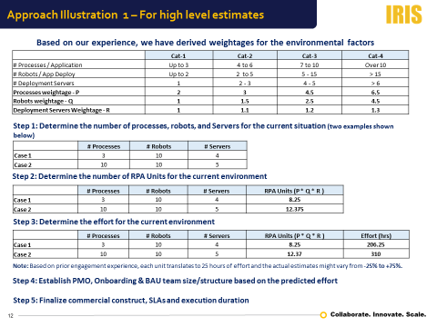

* + **Approach Illustration 2 – For detail level estimates**

This is a 3 Step approach which calculates the Most Likely Estimates for the process automation

It derives the

* One Point Estimate
* Three Point Estimate
* Six Sigma Estimates

And here how the estimation report looks like –

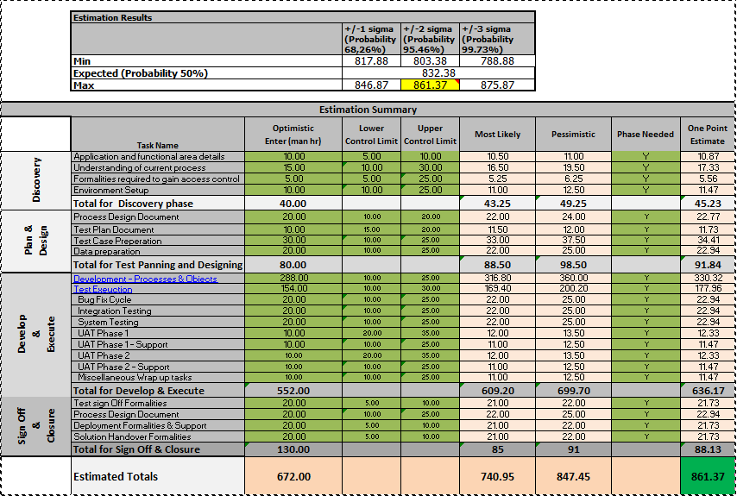

* **Choice of Engagement Models**
* Input- Based
* Output Based
* Outcome Based

**Step 10: Case Study**

1. **Trading Morning Health Checks**

Expected Business Outcome

Expected Technology Outcome

* User-friendly Automation scripts that can be run by business users/ business analysts by adding test data.

Results

Challenges

.

Solution Provided

# Step 11: Conclusion

### 